SIMATS ENGINEERING
ASSESSMENT TOOL 1

COURSE NAME: Database Management Systems
COURSE CODE: CSA05
NAME :P.Jessica Hephzbah
REG NO: 192511425

COURSE OUTCOME COVERED

CO1: Analyze DBMS architecture, different data models, schema types, and design ER/EER diagrams, relational schemas for case-based scenarios by identifying entities and relationships. (BL1, BL2)

Activity Tool : Short Answer Text(High)
Assessment Tool Weightage: 30%

Dr

QUESTIONS Total Marks: 50
Q.No | Question | Bloom's Level | Marks
1 | UPS Product Tracking Information System  UPS prides itself on having up-to-date information on the processing and current location of each shipped item. To do this, UPS relies on a company-wide information system. Shipped items are the heart of the UPS product tracking information system. Shipped items can be characterized by item number (unique), weight, dimensions, insurance amount, destination, and final delivery date. Shipped items are received into the UPS system at a single retail center. Retail centers are characterized by their type, uniqueID, and address. Shipped items make their way to their destination via one or more standard UPS transportation events (i.e., flights, truck deliveries). These transportation events are characterized by a unique scheduleNumber, a type (e.g, flight, truck), and a deliveryRoute. Create an Entity Relationship diagram that captures this information about the UPS system. | BL1 – Remember | 5
2 | Course Management System  Consider a university database for the scheduling of classrooms for final exams. This database could be modeled as the single entity set exam, with attributes course-name, section-number, room-number, and time. Alternatively, one or more additional entity sets could be defined, along with relationship sets to replace some of the attributes of the exam entity set, as  • course with attributes name, department, and c-number  • section with attributes s-number and enrollment, and dependent as a weak entity set on course  • room with attributes r-number, capacity, and building  Show an E-R diagram illustrating the use of all three additional entity sets listed. | BL2 – Understand | 5
3 | University Registrar’s Office Management System  A university registrar’s office maintains data about the following entities:  - courses, including number, title, credits, syllabus, and prerequisites;  - course offerings, including course number, year, semester, section number, instructor(s), timings, and classroom;  - students, including student-id, name, and program;  - instructors, including identification number, name, department, and title.  - Further, the enrollment of students in courses and grades awarded to students in each course they are enrolled for must be appropriately modeled.  Construct an E-R diagram for the registrar’s office. | BL2 – Understand | 5
4 | Hospital Management System  Construct an E-R diagram for a hospital with a set of patients and a set of medical doctors.  Associate with each patient a log of the various tests and examinations conducted. Construct appropriate tables for the above ER Diagram :  Patient(SS#, name, insurance)  Physician ( name, specialization)  Test-log( SS#, test-name, date, time)  Doctor-patient (physician-name, SS#)  Patient-history(SS#, test-name, date) | BL2 – Understand | 5
5 | Company Project Management System  Construct an ER Diagram for Company having following details :  Company organized into DEPARTMENT. Each department has unique name and a particular employee who manages the department. Start date for the manager is recorded. Department may have several locations.  • A department controls a number of PROJECT. Projects have a unique name, number and a single location.  • Company’s EMPLOYEE name, ssno, address, salary, sex and birth date are recorded. An employee is assigned to one department, but may work for several projects (not necessarily controlled by dept). Number of hours/week an employee works on each project is recorded; The immediate supervisor for the employee.  • Employee’s DEPENDENT are tracked for health insurance purposes (dependentname, birthdate, relationship to employee). | BL2 – Understand | 5
6 | Explain schema and instance with examples. Distinguish between logical schema, physical schema, and view schema. | BL1 – Remember | 5
7 | Identify the entities, attributes, and relationships for a Bank Management System and construct its ER diagram. | BL2 – Understand | 5
8 | Explain the Extended ER (EER) model. Describe the concepts of generalization, specialization, and aggregation. | BL2 – Understand | 5
9 | Design an EER diagram for a Hospital Management System incorporating inheritance and weak entities. | BL2 – Understand | 5
10 | Explain the role of a DBA (Database Administrator) and the responsibilities associated with the position. | BL1 – Remember | 5

Code of Conduct:

I ____________________ (Name / Reg No) certify that this submission is my original work and that I have adhered to the guidelines specified for this assessment.
I understand that any violation of academic integrity rules will result in disciplinary action.

Signature of the student:

RUBRICS FOR CALCULATION:

Criteria | Weightage | Level 4 (Exemplary) | Level 3 (Proficient) | Level 2 (Developing) | Level 1 (Beginning)
Concept Identification | 30% | Demonstrates  clear and  complete  understanding of  the concept | Good  understanding  with minor  gaps | Basic  understanding  with some  misconceptions | Poor or  incorrect  understandin  g
Linkages | 25% | Completely  correct answer  with no errors | Mostly correct  with minor  errors | Partially correct  with noticeable  errors | Incorrect or  irrelevant  answer
Organization | 20% | Correctly applies  concepts to solve  the  question/problem | Applies  concepts with  minor  mistakes | Limited or  partially correct  application | No or  incorrect  application
Integration of Literature | 15% | Covers all  required parts of  the question | Covers most  parts with  minor  omissions | Covers only  some parts | Incomplete  or missing  response
Clarity | 10% | Clear, concise,  and well-  organized answer | Understandabl  e with minor  issues | Somewhat  unclear or poorly  structured | Difficult to  understand

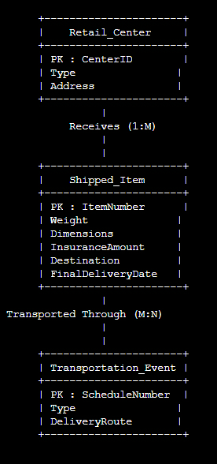
Entity | Primary Key | Other Attributes

Shipped_Item | ItemNumber | Weight, Dimensions, InsuranceAmount, Destination, FinalDeliveryDate

Retail_Center | UniqueID | Type, Address

Transportation_Event | ScheduleNumber | Type, DeliveryRoute

2)
Entity | Attributes | Relationship
Course | C_Number, Name, Department | Has Section
Section | S_Number, Enrollment | Belongs to Course, Scheduled in Room, Has Exam
Room | R_Number, Capacity, Building | Schedules Section
Exam | ExamID, Time | Conducted for Section

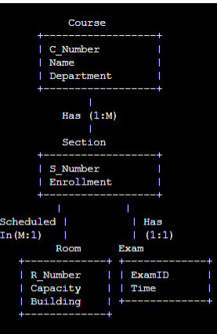

3)
Entity | Attributes | Relationship
Course | CourseNo, Title, Credits, Syllabus, Prerequisites | Has Course_Offering
Course_Offering | SectionNo, Year, Semester, Timings, Classroom | Belongs to Course, Taught by Instructor, Enrolled by Student
Student | StudentID, Name, Program | Enrolls in Course_Offering
Instructor | InstructorID, Name, Department, Title | Teaches Course_Offering

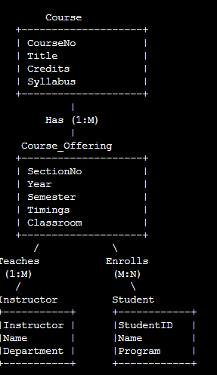

4)
Entity | Attributes | Relationship
Patient | SSNo, Name, Insurance | Treated by Physician, Has Test_Log, Has Patient_History
Physician | PhysicianID, Name, Specialization | Treats Patient
Test_Log | TestID, TestName, Date, Time | Belongs to Patient
Patient_History | HistoryID, TestName, Date | Belongs to Patient

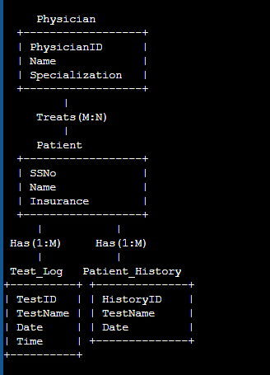

5)
Entity | Attributes | Relationship
Department | DeptName, Location | Employs Employee, Controls Project, Managed by Employee
Employee | SSNo, Name, Address, Salary, Sex, BirthDate | Works in Department, Manages Department, Works on Project, Has Dependent
Project | ProjectNo, Name, Location | Controlled by Department, Assigned to Employee
Dependent | DependentName, BirthDate, Relationship | Belongs to Employee

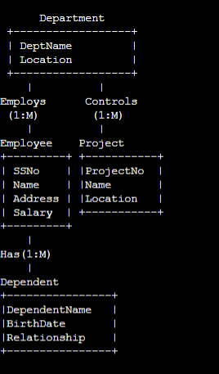

6) Schema: The logical structure of a database that defines tables, attributes, and relationships.
Instance: The actual data stored in the database at a particular point in time.

types of Schema
Schema Type | Description
Logical Schema | Defines the logical structure of the database (tables, attributes, relationships).
Physical Schema | Defines how data is physically stored in memory.
View Schema | Defines how different users view the database.

7)
Entity | Attributes | Relationship
Customer | CustomerID, Name, Address, Phone | Owns Account, Takes Loan
Account | AccountNo, AccountType, Balance | Belongs to Customer, Maintained by Branch
Loan | LoanNo, LoanType, Amount | Taken by Customer, Issued by Branch
Branch | BranchID, BranchName, Location | Maintains Account, Issues Loan

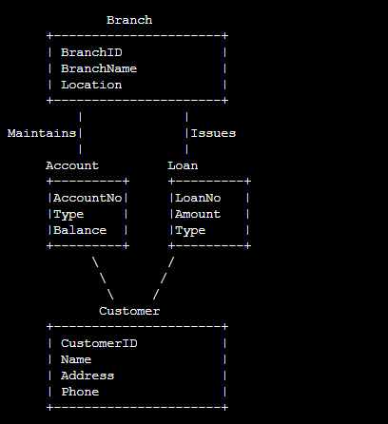

8)
Concept | Description
Generalization | Combines similar lower-level entities into a higher-level entity.
Specialization | Divides a higher-level entity into specialized lower-level entities.
Aggregation | Treats a relationship as a higher-level entity.

9)
Entity | Attributes | Relationship
Person | PersonID, Name, Age | Generalized into Patient and Doctor
Patient | PatientID, Disease | Visits Doctor, Has Medical_Record
Doctor | DoctorID, Specialization | Treats Patient
Medical_Record (Weak Entity) | RecordNo, Diagnosis, Date | Belongs to Patient

